Conveyor station

Solution to exercise 8: Sorting workpieces

Learning objectives
Upon completing this exercise, you should
- be familiar with the function of inductive and opto sensors
- be able to realise control circuits using sensors
- be able to realise simple control systems using FluidSIM®

Problem description
Conveying and sorting tasks are important functions in all production. This exercise consists of designing a conveyor and an accompanying control program with the following characteristics:
the workpieces (containers and lids in red or black) are to be conveyed from the start to the end of the conveyor.
Conveying should start when a workpiece is placed at the start of the conveyor and stop once the workpiece has left the conveyor at the other end.
Silver workpieces should be rejected onto the slide.

Task
- What conveyor setup is needed to realise the specified functions? Create a schematic diagram of the setup showing the arrangement of each component and specify meaningful designations for the components.
- Create an allocation list that shows which slot on the multi-pin plug distributor the electrical components are plugged into.
- Set up the conveyor as per the schematic diagram and wire in accordance with the allocation list.
- Develop a control program using FluidSIM® to monitor the specified functions. Provide an ON/OFF switch. Test the program via simulation.
- Extend the FluidSIM® program to include the multi-pin plug distributor, set the labels as per the allocation list and test your program using the conveyor station.

Aids
- Theory book
- FluidSIM®
- Conveyor station

Name: Class: Date:

- What conveyor setup is needed to realise the specified functions? Create a schematic diagram of the setup showing the arrangement of each component and specify meaningful designations for the components.

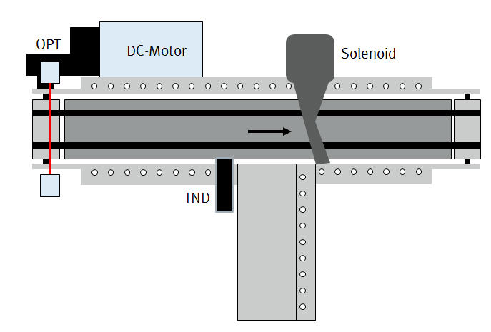
Note: Your schematic diagram can vary slightly; however, the position of the actuators and sensors must be clear and their designations must match the allocation list.

- Create an allocation list that shows which slot on the multi-pin plug distributor the electrical components are plugged into.

Slot | Designation | Explanation
0 | IND | Inductive sensor
1 | K1 | Solenoid/deflector relay output
2 | OPT | Opto sensor
3 | K2 | DC motor relay output

Name: Class: Date:

- Develop a control program using FluidSIM® to monitor the specified functions. Provide an ON/OFF switch. Test the program via simulation.

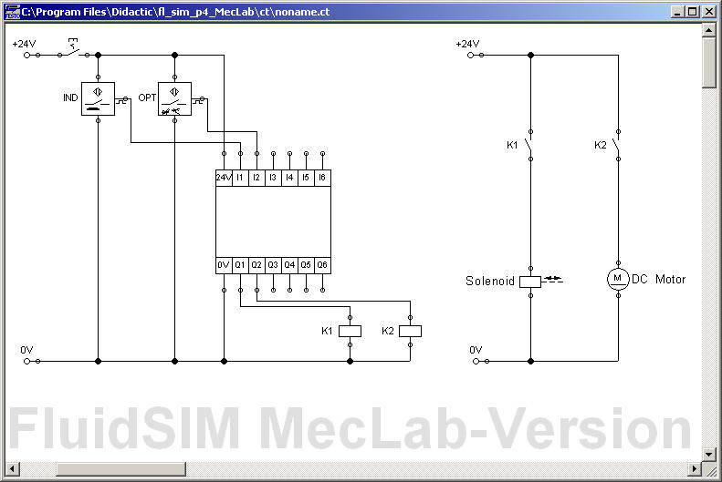

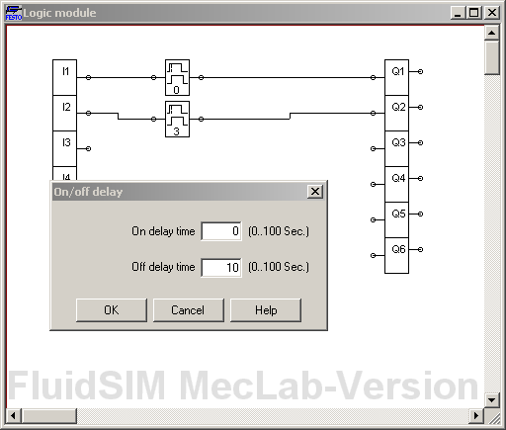

Name: Class: Date:

- Set up the station as per the schematic diagram, install tubing between all pneumatic components and connect the electrical components to the multi-pin plug distributor. Carry out a functional test of the controller using the station.

