Handling station

Solution to exercise 2: Learning about components, symbols and designations

Learning objective
Upon completing this exercise, you should
- be familiar with the symbols and designations of key pneumatic components

Problem description
All automated systems use a range of components such as sensors, valves, motors, etc. It is important to describe the function of the system clearly and simply. This is done using, among other things electrical, pneumatic and hydraulic circuit diagrams.
To understand these circuit diagrams, you must be familiar with the symbols used.

Task
- Match the components with the correct symbols and designations. Do this by entering the number assigned to the component in the correct fields in the "Symbol" and "Designation" columns.

Aids
- Theory book
- FluidSIM® online help
- Data sheets

Name: Class: Date:

- Match the components with the correct symbols and designations. Do this by entering the number assigned to the component in the correct fields in the "Symbol" and "Designation" columns.

Component | Symbol | Designation
1  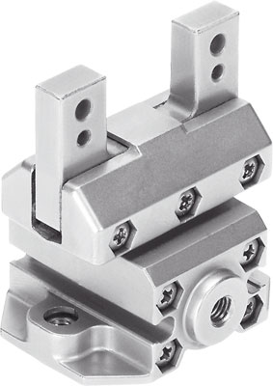 | [ 2 ] | [ 2 ]  One-way flow control valve
2  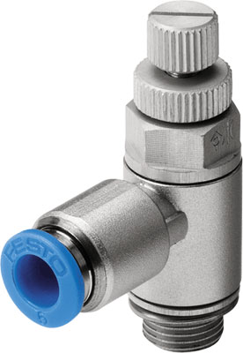 | [ 3 ] | [ 6 ]  Double-acting cylinder
3  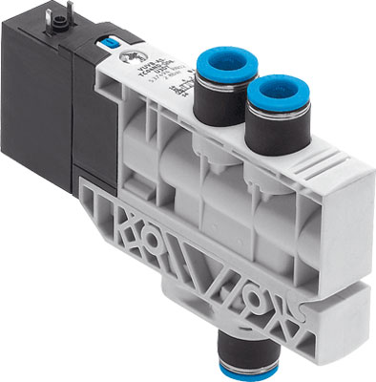 | [ 1 ] | [ 3 ]  4/2-way single solenoid valve
4  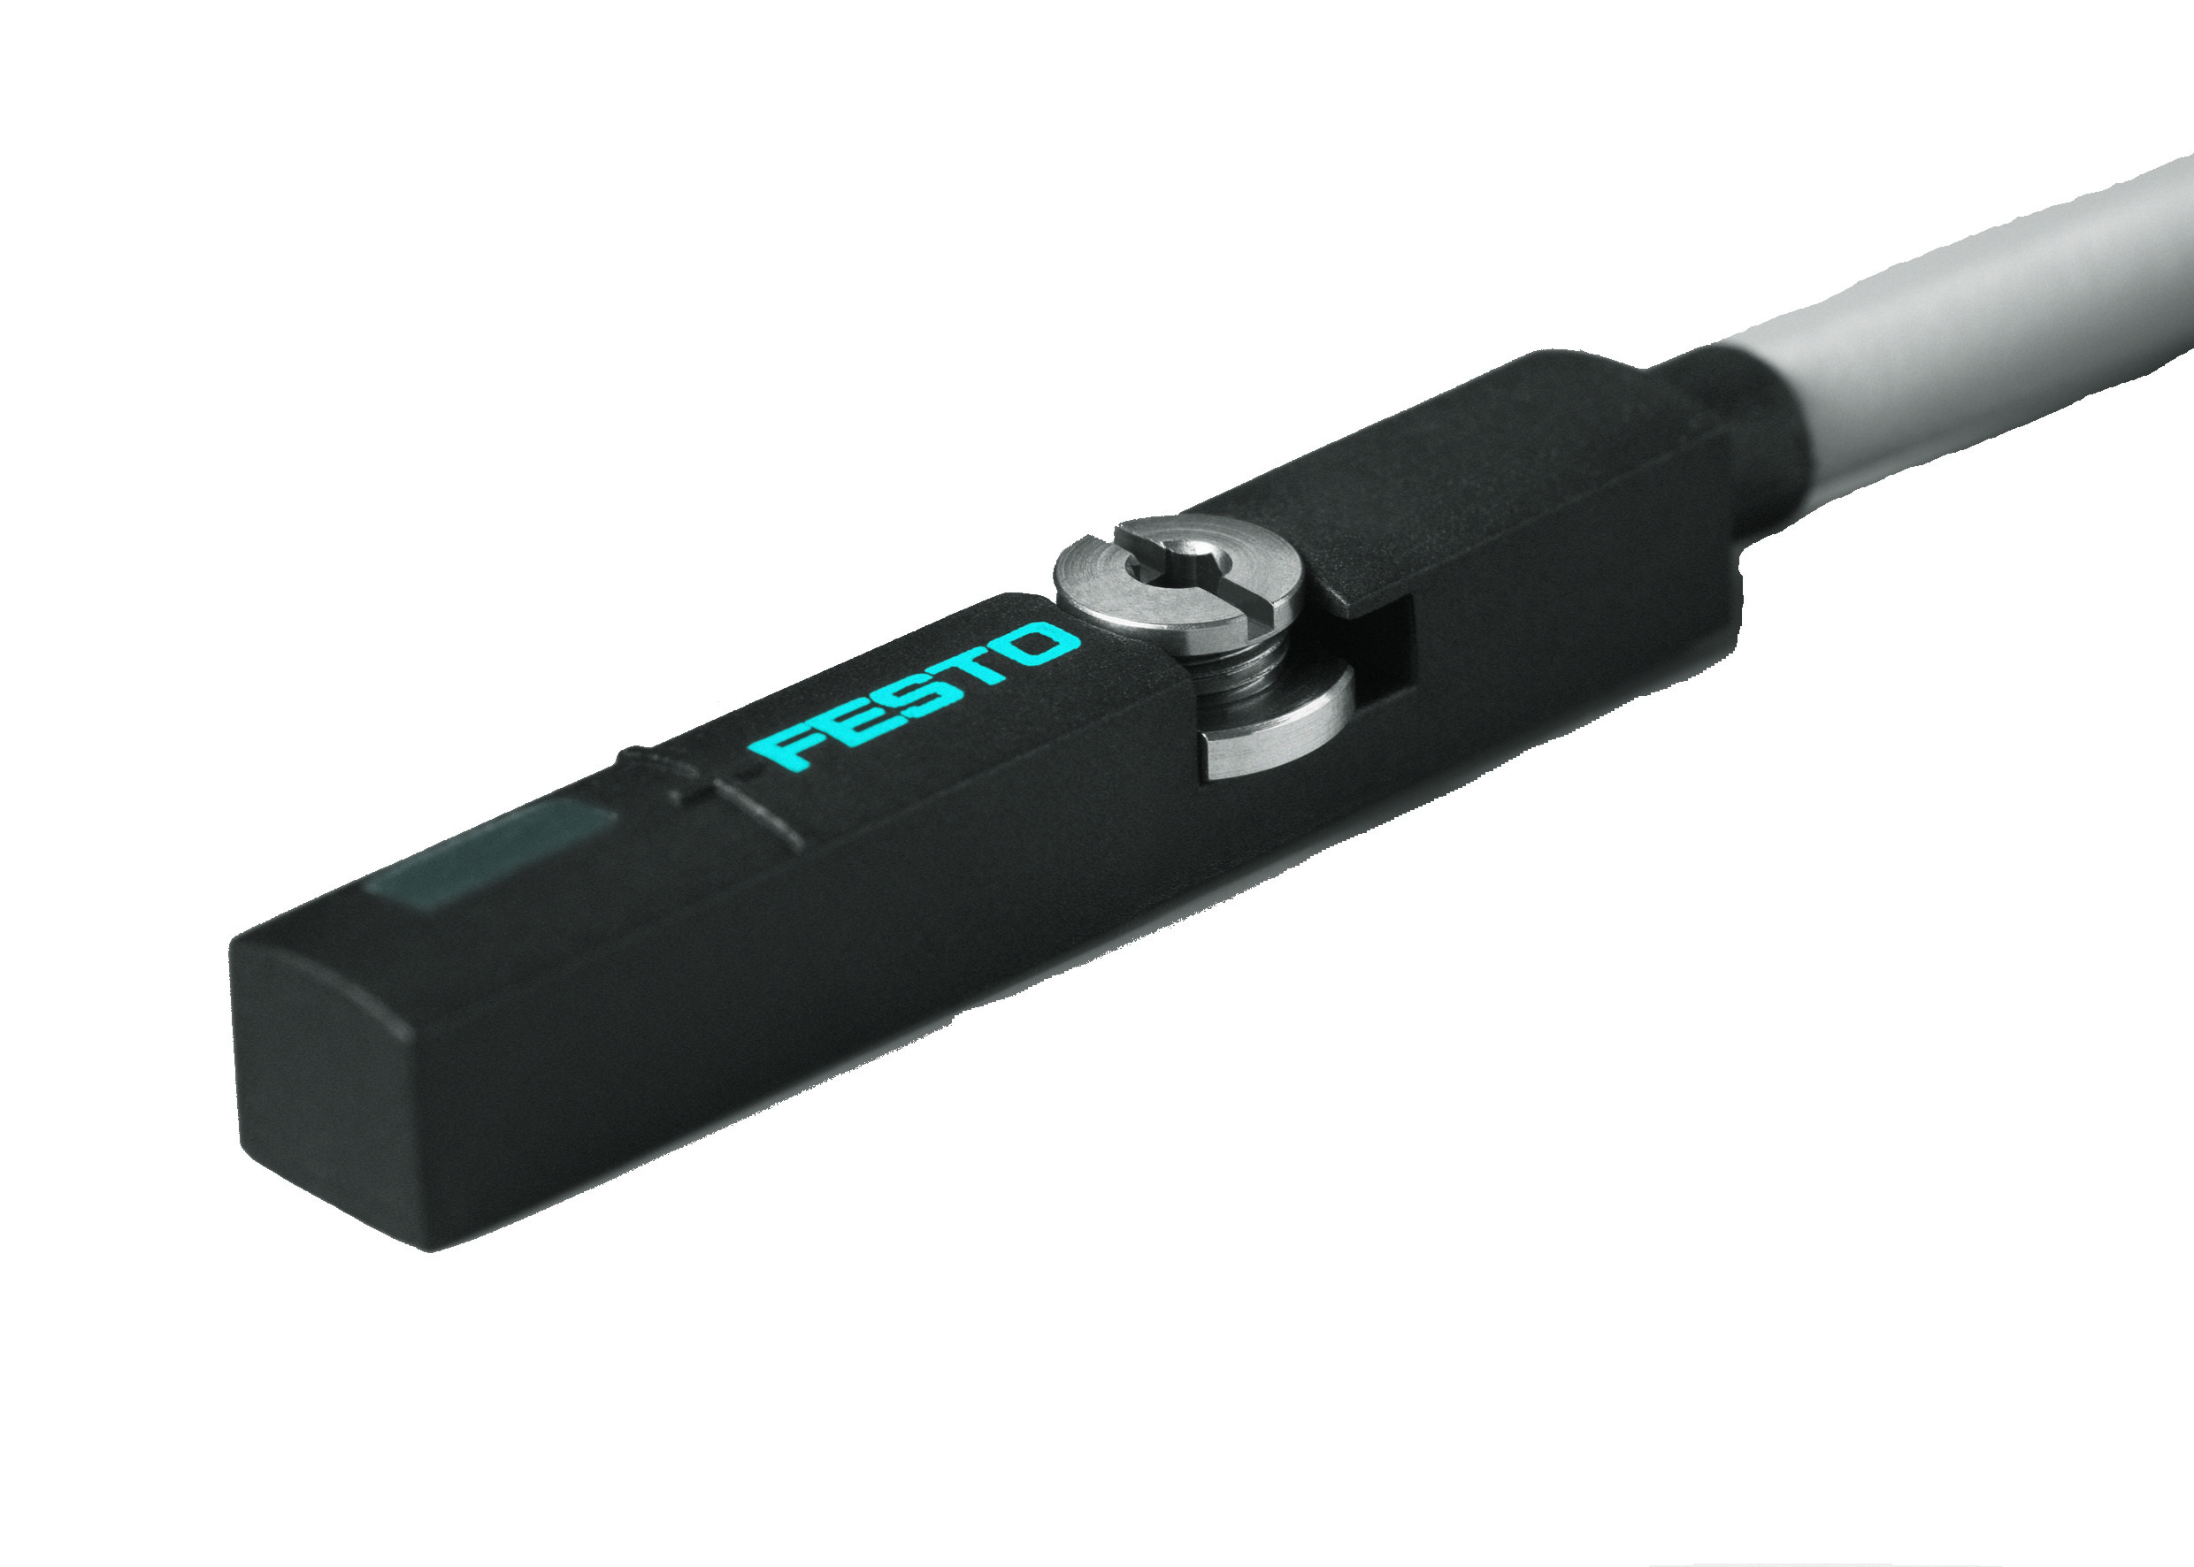 | [ 5 ] | [ 1 ]  Gripper
5  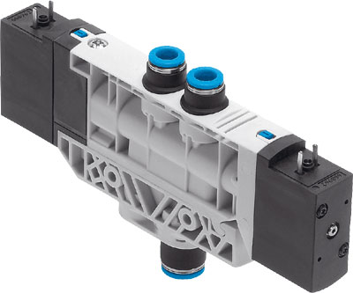 | [ 6 ] | [ 4 ]  Inductive proximity sensor
6  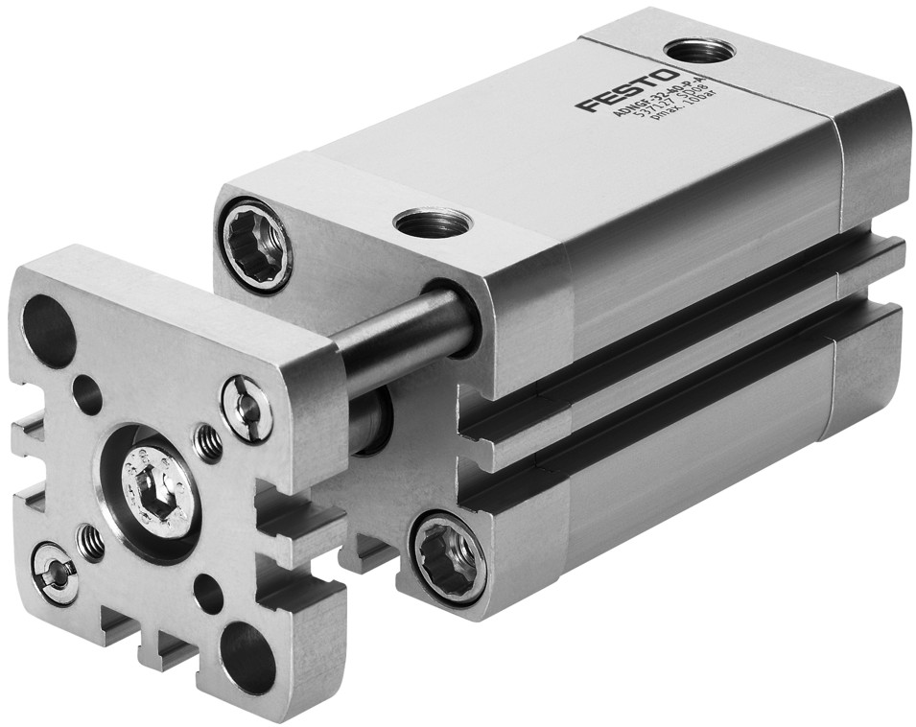 | [ 4 ] | [ 5 ]  4/2-way double solenoid valve

