Stacking magazine station

Solution to exercise 4: Creating schematic and circuit diagrams

Learning objectives
Upon completing this exercise, you should
- be able to create schematic diagrams, pneumatic circuit diagrams and allocation lists

Problem description
Engineers use schematic diagrams, technical drawings, part lists or circuit diagrams to describe machines. These tools can be used to describe machines or machine parts efficiently and clearly.

Tasks
- Create a schematic diagram for the stacking magazine pictured showing the function and position of the important components.
- Create an allocation list that specifies which sensor or actuator is plugged into which slot on the multi-pin plug distributor.
- Create a pneumatic circuit diagram of the station using FluidSIM®.

Aids
- Theory book
- FluidSIM® sample circuit diagrams

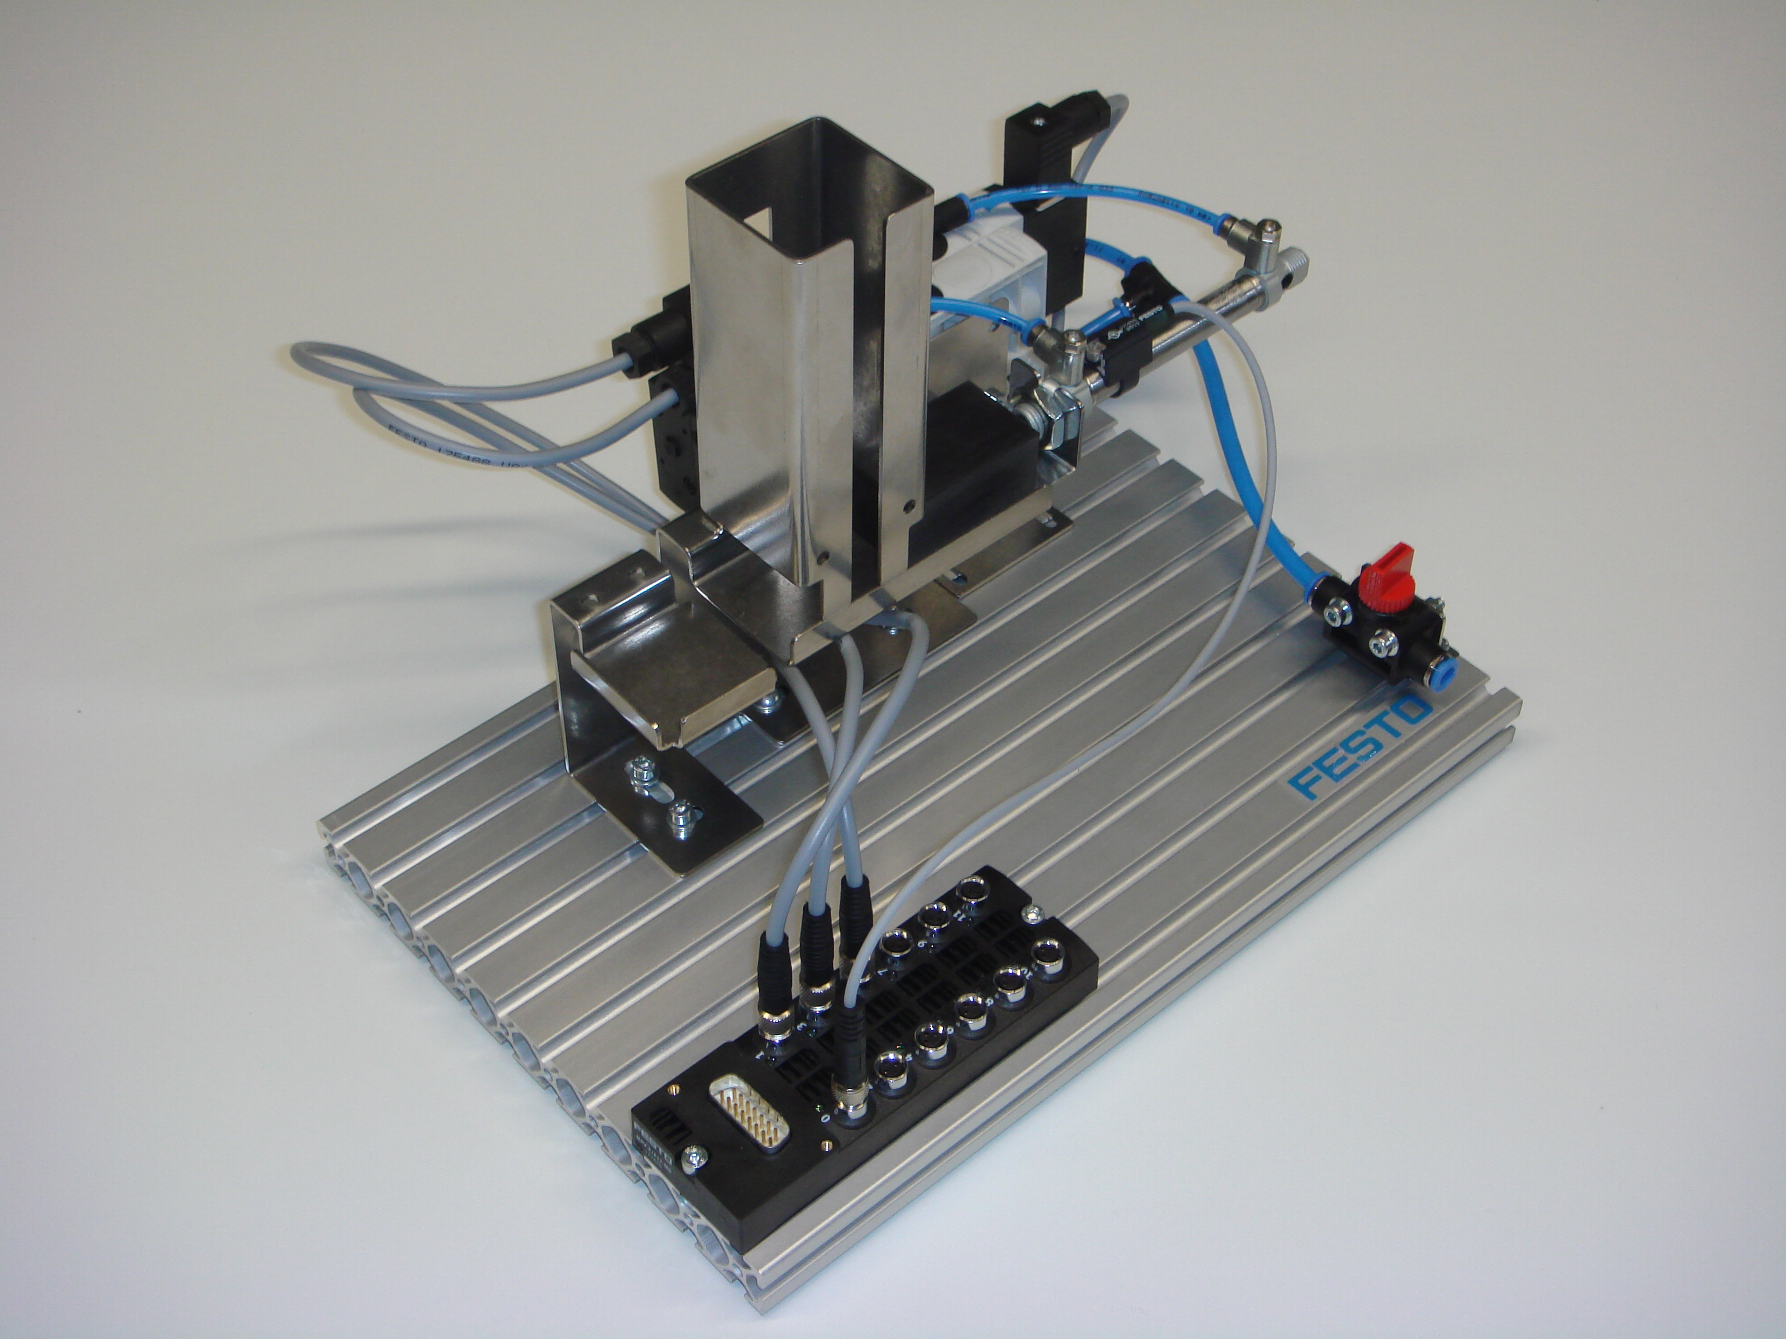
Picture of the station

Name: Class: Date:

- Create a schematic diagram for the stacking magazine pictured showing the function and position of the key components.

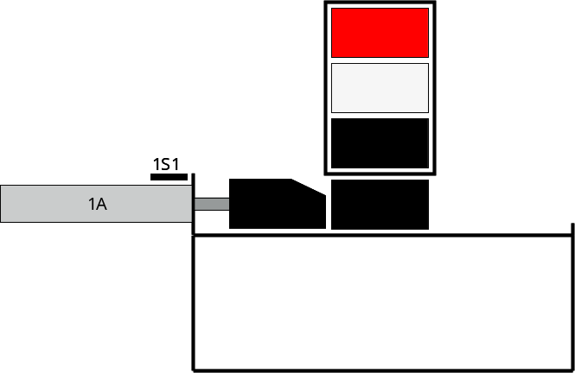

Note
Your schematic diagram can vary slightly; however, the arrangement of the drives and sensors must be clear.

- Create an allocation list that specifies which sensor or actuator is plugged into which slot on the multi-pin plug distributor.

Slot | Designation | Description
0 | 1S1 | Magnetic proximity sensor at cylinder 1A
1 | 1M1 | Solenoid coil 1 of valve 1 (advance cylinder 1A)
3 | 1M2 | Solenoid coil 2 of valve 1 (retract cylinder 1A)

Note
The designation may be different; however, it must match the circuit diagram.

Name: Class: Date:

- Create a pneumatic circuit diagram of the station using FluidSIM®.



