Stacking magazine station

Solution to exercise 5: Controlling a single-acting cylinder

Learning objectives
Upon completing this exercise, you should
- be able to select the components of an electropneumatic circuit
- be able to design electropneumatic circuits
- be able to control a single-acting cylinder using FluidSIM®

Problem description
An important function of the stacking magazine station is pressing together containers and lids. A controller is to be designed for this purpose.

A vertically arranged pneumatic cylinder which is supplied with air by a solenoid valve and is actuated via a PC is to be used for pressing in. The cylinder should advance when a pushbutton is actuated and remain advanced for as long as the pushbutton remains actuated. An important parameter is that for safety reasons, the cylinder must also return to the upper end position in the event of a power failure.

Tasks
- Select a suitable cylinder from the two available.
Explain the reasons for your selection.
- Select a suitable valve from the four available.
Explain the reasons for your selection.
- Design a pneumatic circuit diagram for the components you selected.
Carry out a functional test via simulation.
- Complete the electrical circuit diagram by including a suitable actuating element and transfer the solution to FluidSIM®. Carry out a functional test via simulation.
- Extend the circuit so that the cylinder in the stacking magazine station can be actuated.
Test its operability.

Aids
- Theory book
- FluidSIM®

Name: Class: Date:

- Select a suitable cylinder from the two available.
Explain the reasons for your selection.

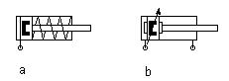
a) single-acting cylinder; b) double-acting cylinder

Reasons
The single-acting cylinder makes more sense for the task at hand. The integrated spring means it returns to the retracted (=upper) end position even in the event of pressure failure, whereas the double-acting cylinder always requires compressed air for this.

- Select a suitable valve from the four available.
Explain the reasons for your selection.

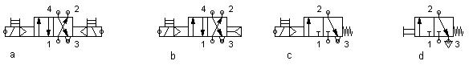
a) 4/2-way double solenoid valve
b) 4/2-way single solenoid valve
c) 3/2-way normally closed solenoid valve
d) 3/2-way normally closed valve, manually-actuated

Reasons
The 3/2-way normally closed solenoid valve makes sense for actuating the single-acting cylinder. It exhausts the cylinder in the event of a power failure (so that it travels to the advanced end position). The 4/2-way valves have one output too many for a single-acting cylinder, while the manually-actuated 3/2-way valve cannot be controlled via a PC.

Name: Class: Date:

- Design a pneumatic circuit diagram for the components you selected and carry out a functional test via simulation using FluidSIM®. The components required are the single-acting cylinder, the 3/2-way solenoid valve and a compressed air supply. Test the circuit in simulation mode by clicking on the valve’s manual override with the mouse.

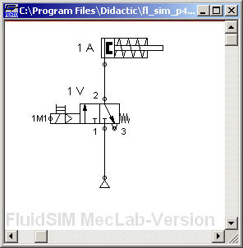

Name: Class: Date:

- Complete the electrical circuit diagram by selecting a suitable actuating component. The actuating components available are:

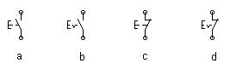
a) pushbutton (N/O contact), b) detenting pushbutton (N/O contact), c) pushbutton (N/C contact), d) detenting pushbutton (N/C contact)

The pushbutton with N/O contacts makes sense here. When it is actuated, the circuit is closed and the cylinder advances.

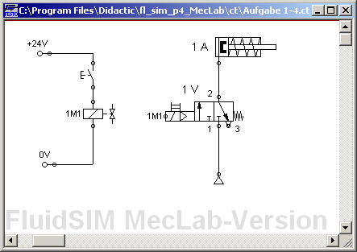

Name: Class: Date:

- Transfer the solution to FluidSIM® and carry out a functional test via simulation.

- Extend the circuit so that the cylinder in the stacking magazine station can be actuated.
Test its operability.
Do this by extending your circuit diagram to include the multi-pin plug symbol and allocating the designation for the solenoid coil to the slot where the solenoid coil is actually plugged in.

